Assessment Project  
Tashia Hernandez & Kristen Cocco

**Standards for all parts:**   
SC2.4.3.b Observe and describe simple daily changes in weather  
SC2.4.3.c Describe simple seasonal weather indicators and how they impact student choices (activities, clothing)

LA 0.1.5.b Relate new grade level vocabulary to prior knowledge and use in new situations  
SC2.4.3.b Observe and describe simple daily changes in weather

1.  Pre-assessment:

* Objectives: The students will be able to describe their favorite season using illustrations for a pre-assessment.
* Assessment: Each student will draw a picture of the season of their choice with details. The teacher will assess based on accuracy of the characteristics used for each seasonal picture.
* Narrative: A challenge may arise if some students don’t have any background knowledge, while others are familiar with the difference in seasons. Especially in kindergarten, the students will come to school with different levels of knowledge and experience in this area.

2.  Traditional assessment

* Objectives: The students will be able to demonstrate knowledge about the weather and clothing worn during each of the four seasons.
* Assessment: The students will complete a test that consists of matching, drawing a picture, and multiple choice with accuracy.
* Narrative: A challenge could be making sure the students have enough knowledge built during instruction and can apply this knowledge to the summative assessment.
* Copy of the test is at the end of this document.

3.  Authentic

* Objectives: The students will be able to create a mural using paint to show the changes in nature from season to season.
* Assessment: The students will be divided into four groups and will be directed to paint a tree that is assigned to a specific season. The teacher will paint the trees ahead of time onto a very large piece of paper. Group one will be expected to paint a winter tree and should show a tree without leaves that is covered in ice and snow. Group two will be expected to paint a spring tree that shows buds, flowers, and minimal leaves. Group three will be expected to paint summer trees that are bright green and full of leaves. Group four will be expected to paint a fall tree with brown, orange, red and yellow leaves that may be falling. The teacher will assess this based off of the rubric at the end of the document.
* Narrative: It may be difficult for students to show the specific details of each season. This will be done in the class so the teacher will ask the students questions to guide them during their painting time.

4.  Affective assessment

* Objectives: Students will act and speak appropriately during classroom discussions and group activity.
* Assessment: The teacher will observe student interactions as well as completion of the overall project. Teacher will address this in the rubric for the entire unit.
* Narrative: Challenges may be if the students have issues working well together due to lack of experience of independence during group work. The teacher will try her best to observe all students individually and grouped and assist students as needed.

5.  Rubric

* Students will be graded on the **completed mural** based off the following rubric.

|  |  |  |  |
| --- | --- | --- | --- |
|  | Student showed all characteristics of the seasons 3 | Students showed partial characteristics of the seasons  2 | Students showed none of the characteristics of the seasons  1 |
| **Winter** |  |  |  |
| **Spring** |  |  |  |
| **Summer** |  |  |  |
| **Fall** |  |  |  |
| **TOTAL** |  |  |  |

OVERALL POINTS EARNED: _____________  
  
 **Name: _______________________________**

**Weather & Seasons**

**Summative Assessment**

**Draw a line to match the seasons**

**Summer** **Spring** **Winter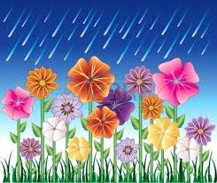 Fall**



**Draw a Picture….**

**Rainy**

**Sunny**

**Windy**

**Snowy**

**Circle the proper clothing for each season**

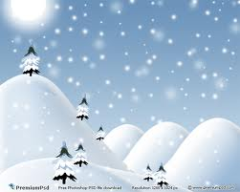  
  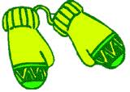





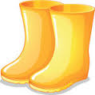  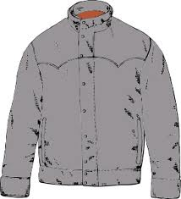 

  
   

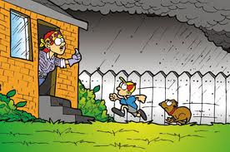

https://encrypted-tbn1.gstatic.com/images?q=tbn:ANd9GcT-pNo29O7ZfKRkrx2tAD147DGt1sKf5tZcHt4GXC4DtSuqoJ4npA 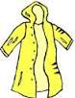  

**Weather Unit Grading  
This will be used to grade the entire unit as a whole based on the following criteria.**

**Criterion** **Student Performance**

|  |  |  |  |  |
| --- | --- | --- | --- | --- |
|  | **Student Completely Understands Content**  **3** | **Student Somewhat Understands Content**  **2** | **Student Does Not Understand Content 1** | **Score** |
| **Students showed understanding of the difference of the seasons throughout each lesson** |  |  |  |  |
| **Student showed understanding of seasons through summative assessment (3 for an A grade, 2 for a B grade, 1 for a C, D or F grade)** |  |  |  |  |
| **Student completed mural activity accurately (copy grade here)** |  |  |  |  |
| **Student understand what behavior is expected of them and demonstrated appropriate behaviors** |  |  |  |  |
| **Summative Assessment Score** |  |  |  |  |

Overall Total Here